Different Coat

( User Manual )

## This manual explains the basic operation of the "PaintShopMenu" program, hereinafter referred to as the program.

## How to start?

The program runs in the Java environment. Eclipse is the most common (<https://www.eclipse.org/>). Nothing prevents you if you have your favourite environment. In Eclipse, select the "PaintShopMenu" class and click the Run button.

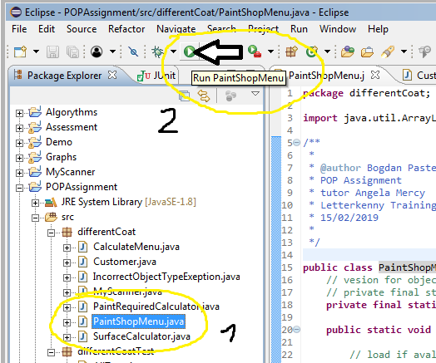

## What's next?

The program will display the Menu, you only need to enter your choice on the keyboard.

If only it is possible, the program will load the previously saved list of clients. If not, the program will notify us and create an example list.

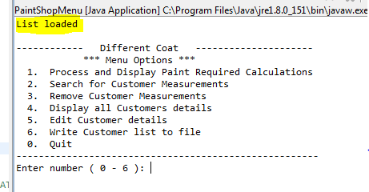

## Adding a new client to the list (option 1).

After selecting the first option, the program will ask us for some necessary data. On their basis, it will create a new client and add it to the list. In addition, the program will display customer data in the format kept in the list.

Attention. Data is validated and formatted before adding to the list, so it can look different while maintaining its value. This applies first of all to the telephone number.

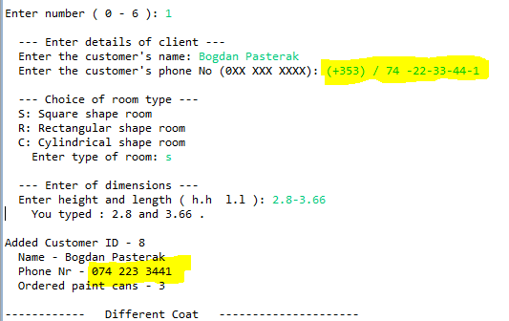

Entering the dimensions of the room takes place in a single line in a specific order. Separator can be any characters like space, dot, backslash, tabulator, hyphen or coma. An exception is the dot (divides numbers into decimal numbers). The order of the entered data is important.

## Finding customer data (option 2)

If we know the client's Id, we can view its saved data in the list. After selecting option 2, the program will ask us for the customer ID and then will display the data. If we give the wrong number, we will be informed and asked to enter the number again.

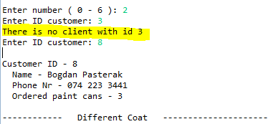

## Remove customer (option 3)

This option works almost identically to the option above. It distinguishes only that after writing out the data deletes the client from the list. Data about the client can be recovered if the list was previously saved.

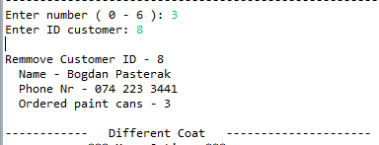

## Display all customer (option 4)

Displays all clients currently on the list.

## Edit customer (option 5)

If we want to change customer data (name, phone or ordered paint), we can do it using option 5. Similarly to option 1, the program will guide us through data editing. The difference is that we can leave the editions of each given by pressing Enter. Of course, at the beginning we have to give the client's ID for editing.

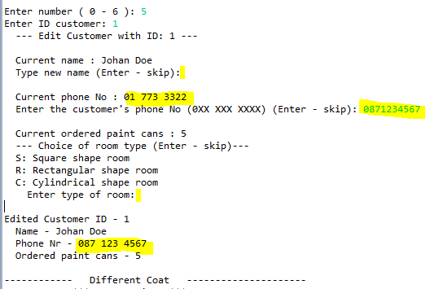

## Save list (option 6)

After finishing work, it is worth saving the results of our work to a file before starting the program. This can be done with the help of option 6. We will be informed about the success of the write operation, or possibly about problems.

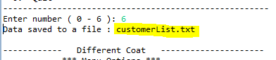

## Quit (option 0)

The last item in the menu allows you to end the program.

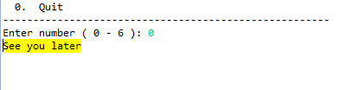

# FAQ - Frequently asked questions

### Can I see (edit) the data stored in the file?

- Of course. After saving the data, the program gives the path to the file.

- It is a text file so it can be opened with the help of any editor, even Notepad.

- When editing data, you must follow several rules:

* The first line of the text must remain unchanged, it is used to authorize the data.
* Each customer is another, separate text line.
* The client consists of four fields separated by tabulator.
* The first field is ID. Must be in the ascending order.
* The second is name
* Third, phone number. It must be correct, the program will format it.
* The fourth, the value to hold the quantity of ordered paint cans.

- In the event of a data mismatch, the program has rejected the data of this client and others following it.

#### More answers will appear as you pour questions.

Bogdan Pasterak

15/02/2019